**Exercise 1: Configuring a Basic Spring Application**

**Pom.xml**

<dependencies>  
 <dependency>  
 <groupId>org.springframework</groupId>  
 <artifactId>spring-context</artifactId>  
 <version>5.3.34</version>  
 </dependency>  
</dependencies>

**BookRepository.java**

package org.library.repository;  
  
public class BookRepository {  
 public void saveBook(String title) {  
 System.*out*.println("Saving book: " + title);  
 }  
}

**BookService.java**

package org.library.service;  
  
import org.library.repository.BookRepository;  
  
public class BookService {  
 private BookRepository bookRepository;  
  
 public void setBookRepository(BookRepository bookRepository) {  
 this.bookRepository = bookRepository;  
 }  
  
 public void addBook(String title) {  
 System.*out*.println("BookService: Adding book...");  
 bookRepository.saveBook(title);  
 }  
}

**Main.java**

package org.library;  
  
import org.library.service.BookService;  
import org.springframework.context.ApplicationContext;  
import org.springframework.context.support.ClassPathXmlApplicationContext;  
  
public class Main {  
 public static void main(String[] args) {  
 ApplicationContext context = new ClassPathXmlApplicationContext("applicationContext.xml");  
 BookService bookService = (BookService) context.getBean("bookService");  
 bookService.addBook("Spring in Action");  
 }  
}

**resources/applicationContext.xml**

<?xml version="1.0" encoding="UTF-8"?>  
<beans xmlns="http://www.springframework.org/schema/beans"  
 xmlns:xsi="http://www.w3.org/2001/XMLSchema-instance"  
 xsi:schemaLocation="  
 http://www.springframework.org/schema/beans  
 http://www.springframework.org/schema/beans/spring-beans.xsd">  
  
 <bean id="bookRepository" class="org.library.repository.BookRepository"/>  
 <bean id="bookService" class="org.library.service.BookService">  
 <property name="bookRepository" ref="bookRepository"/>  
 </bean>  
  
</beans>

**Output :**

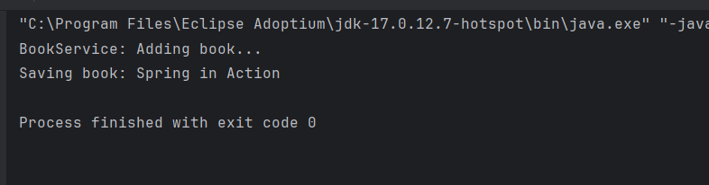

**Exercise 2: Implementing Dependency Injection**

**resources/applicationContext.xml**

<?xml version="1.0" encoding="UTF-8"?>  
<beans xmlns="http://www.springframework.org/schema/beans"  
 xmlns:xsi="http://www.w3.org/2001/XMLSchema-instance"  
 xsi:schemaLocation="  
 http://www.springframework.org/schema/beans  
 http://www.springframework.org/schema/beans/spring-beans.xsd">  
 <bean id="bookRepository" class="org.library.repository.BookRepository"/>  
 <bean id="bookService" class="org.library.service.BookService">  
 <property name="bookRepository" ref="bookRepository"/>  
 </bean>  
  
</beans>

**BookService.java**

package org.library.service;  
  
import org.library.repository.BookRepository;  
  
public class BookService {  
 private BookRepository bookRepository;  
  
  
 public void setBookRepository(BookRepository bookRepository) {  
 this.bookRepository = bookRepository;  
 }  
  
 public void addBook(String title) {  
 System.*out*.println("BookService: Adding book...");  
 bookRepository.saveBook(title);  
 }  
}

**Main.java**

package org.library;  
  
import org.library.service.BookService;  
import org.springframework.context.ApplicationContext;  
import org.springframework.context.support.ClassPathXmlApplicationContext;  
  
public class Main {  
 public static void main(String[] args) {  
 ApplicationContext context = new ClassPathXmlApplicationContext("applicationContext.xml");  
 BookService bookService = (BookService) context.getBean("bookService");  
  
 bookService.addBook("Effective Java");  
 }  
}

**Output :**

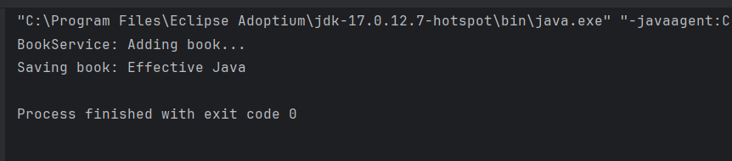

**Exercise 4: Creating and Configuring a Maven Project**

**pom.xml**

<project xmlns="http://maven.apache.org/POM/4.0.0"

xmlns:xsi="http://www.w3.org/2001/XMLSchema-instance"

xsi:schemaLocation="http://maven.apache.org/POM/4.0.0

http://maven.apache.org/xsd/maven-4.0.0.xsd">

<modelVersion>4.0.0</modelVersion>

<groupId>com.library</groupId>

<artifactId>LibraryManagement</artifactId>

<version>1.0-SNAPSHOT</version>

<dependencies>

<dependency>

<groupId>org.springframework</groupId>

<artifactId>spring-context</artifactId>

<version>5.3.34</version>

</dependency>

<dependency>

<groupId>org.springframework</groupId>

<artifactId>spring-aop</artifactId>

<version>5.3.34</version>

</dependency>

<dependency>

<groupId>org.springframework</groupId>

<artifactId>spring-webmvc</artifactId>

<version>5.3.34</version>

</dependency>

<dependency>

<groupId>javax.servlet</groupId>

<artifactId>javax.servlet-api</artifactId>

<version>4.0.1</version>

<scope>provided</scope>

</dependency>

</dependencies>

**Configure Maven :**

<build>

<plugins>

<plugin>

<groupId>org.apache.maven.plugins</groupId>

<artifactId>maven-compiler-plugin</artifactId>

<version>3.10.1</version>

<configuration>

<source>1.8</source>

<target>1.8</target>

</configuration>

</plugin>

</plugins>

</build>

**Exercise 5: Configuring the Spring IoC Container**

**applicationContext.xml**

<?xml version="1.0" encoding="UTF-8"?>  
<beans xmlns="http://www.springframework.org/schema/beans"  
 xmlns:xsi="http://www.w3.org/2001/XMLSchema-instance"  
 xsi:schemaLocation="  
 http://www.springframework.org/schema/beans  
 http://www.springframework.org/schema/beans/spring-beans.xsd">  
 <bean id="bookRepository" class="org.library.repository.BookRepository"/>  
 <bean id="bookService" class="org.library.service.BookService">  
 <property name="bookRepository" ref="bookRepository"/>  
 </bean>  
  
</beans>

**BookRepository.java**

package org.library.repository;  
  
public class BookRepository {  
 public void saveBook(String title) {  
 System.*out*.println("BookRepository: Saving book - " + title);  
 }  
}

**BookService.java**

package org.library.service;  
  
import org.library.repository.BookRepository;  
  
public class BookService {  
 private BookRepository bookRepository;  
  
 public void setBookRepository(BookRepository bookRepository) {  
 this.bookRepository = bookRepository;  
 }  
  
 public void addBook(String title) {  
 System.*out*.println("BookService: Adding book...");  
 bookRepository.saveBook(title);  
 }  
}

**Main.java**

package org.library;  
  
import org.library.service.BookService;  
import org.springframework.context.ApplicationContext;  
import org.springframework.context.support.ClassPathXmlApplicationContext;  
  
public class Main {  
 public static void main(String[] args) {  
 ApplicationContext context = new ClassPathXmlApplicationContext("applicationContext.xml");  
  
 BookService bookService = (BookService) context.getBean("bookService");  
 bookService.addBook("Clean Code");  
 }  
}

**Output :**

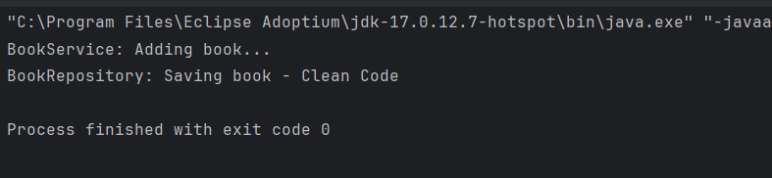

**Exercise 7: Implementing Constructor and Setter Injection**

**resources/applicationContext.xml**

<?xml version="1.0" encoding="UTF-8"?>  
<beans xmlns="http://www.springframework.org/schema/beans"  
 xmlns:xsi="http://www.w3.org/2001/XMLSchema-instance"  
 xsi:schemaLocation="http://www.springframework.org/schema/beans  
 http://www.springframework.org/schema/beans/spring-beans.xsd">  
  
 <bean id="bookRepository" class="org.library.repository.BookRepository"/>  
 <bean id="bookService" class="org.library.service.BookService">  
  
 <constructor-arg ref="bookRepository"/>  
 <property name="libraryName" value="City Central Library"/>  
 </bean>  
  
</beans>

**BookService.java**

package org.library.service;  
  
import org.library.repository.BookRepository;  
  
public class BookService {  
 private BookRepository bookRepository;  
 private String libraryName;  
  
 public BookService(BookRepository bookRepository) {  
 this.bookRepository = bookRepository;  
 }  
  
 public void setLibraryName(String libraryName) {  
 this.libraryName = libraryName;  
 }  
  
 public void addBook(String title) {  
 System.*out*.println("[" + libraryName + "] BookService: Adding book...");  
 bookRepository.saveBook(title);  
 }  
}

**Main.java**

package org.library;  
  
import org.library.service.BookService;  
import org.springframework.context.ApplicationContext;  
import org.springframework.context.support.ClassPathXmlApplicationContext;  
  
public class Main {  
 public static void main(String[] args) {  
 ApplicationContext context = new ClassPathXmlApplicationContext("applicationContext.xml");  
  
 BookService bookService = (BookService) context.getBean("bookService");  
 bookService.addBook("The Pragmatic Programmer");  
 }  
}

**Output :**

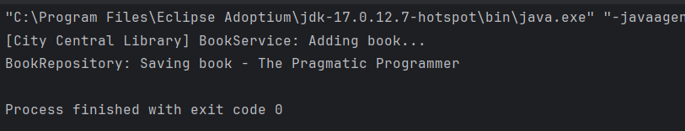

**Exercise 9: Creating a Spring Boot Application**

**LibraryManagementApplication.java**

package com.library.LibraryManagement;  
  
import org.springframework.boot.SpringApplication;  
import org.springframework.boot.autoconfigure.SpringBootApplication;  
  
@SpringBootApplication  
public class LibraryManagementApplication {  
  
 public static void main(String[] args) {  
 SpringApplication.*run*(LibraryManagementApplication.class, args);  
 }  
  
}

**application.properties**

spring.application.name=LibraryManagement  
spring.datasource.url=jdbc:h2:mem:librarydb  
spring.datasource.driverClassName=org.h2.Driver  
spring.datasource.username=sa  
spring.datasource.password=  
spring.jpa.database-platform=org.hibernate.dialect.H2Dialect  
spring.jpa.hibernate.ddl-auto=update  
  
spring.h2.console.enabled=true  
spring.h2.console.path=/h2-console

**BookController.java**

package com.library.LibraryManagement.controller;  
  
  
import com.library.LibraryManagement.entity.Book;  
import com.library.LibraryManagement.repository.BookRepository;  
import org.springframework.beans.factory.annotation.Autowired;  
import org.springframework.web.bind.annotation.*;  
  
import java.util.List;  
  
@RestController  
@RequestMapping("/api/books")  
public class BookController {  
  
 @Autowired  
 private BookRepository bookRepository;  
  
 @GetMapping  
 public List<Book> getAllBooks() {  
 return bookRepository.findAll();  
 }  
  
 @GetMapping("/{id}")  
 public Book getBookById(@PathVariable Long id) {  
 return bookRepository.findById(id).orElse(null);  
 }  
  
 @PostMapping  
 public Book createBook(@RequestBody Book book) {  
 return bookRepository.save(book);  
 }  
  
 @PutMapping("/{id}")  
 public Book updateBook(@PathVariable Long id, @RequestBody Book updatedBook) {  
 return bookRepository.findById(id).map(book -> {  
 book.setTitle(updatedBook.getTitle());  
 book.setAuthor(updatedBook.getAuthor());  
 return bookRepository.save(book);  
 }).orElse(null);  
 }  
  
 @DeleteMapping("/{id}")  
 public void deleteBook(@PathVariable Long id) {  
 bookRepository.deleteById(id);  
 }  
}

**Book.java**

package com.library.LibraryManagement.entity;  
  
  
import jakarta.persistence.*;  
  
@Entity  
public class Book {  
 @Id  
 @GeneratedValue(strategy = GenerationType.*IDENTITY*)  
 private Long id;  
  
 private String title;  
 private String author;  
  
 public Book() {}  
  
 public Book(String title, String author) {  
 this.title = title;  
 this.author = author;  
 }  
   
 public Long getId() { return id; }  
  
 public String getTitle() { return title; }  
 public void setTitle(String title) { this.title = title; }  
  
 public String getAuthor() { return author; }  
 public void setAuthor(String author) { this.author = author; }  
}

**BookRepository.java**

package com.library.LibraryManagement.repository;  
  
  
  
import com.library.LibraryManagement.entity.Book;  
import org.springframework.data.jpa.repository.JpaRepository;  
  
public interface BookRepository extends JpaRepository<Book, Long> {  
}

**Output :**

